Practical - 2
Practical Title: Semantic HTML5 Pages with Accessibility-Ready Structure
Problem Definition: Develop static HTML5 skeletons for at least 10 StudentHub pages such as Home, About, Register, Login, Dashboard, Events, Profile, Contact, Admin, FAQ, and Feedback. Use semantic tags and accessibility-friendly structure.

Theory

1. Are semantic tags such as header, nav, main, section, article, aside, and footer used properly?
Answer: Yes, semantic tags are used properly to organize the content and improve the structure, readability, and accessibility of the web pages.

2. Are form labels, headings, image alt text, and navigation links accessible?
Answer: Yes, proper form labels, headings, image alt text, and navigation links are used to make the website accessible and user-friendly for all users.

3. Is the page structure consistent across all pages?
Answer: Yes, all pages follow a consistent structure with the same header, navigation, main content area, and footer, providing a uniform user experience.

Implementation/ Output/Result
- Created student hub pages using HTML
- Push the files to the Repo
- Added navigation Links
- Connected all the pages

Evidence of Work (Screenshots)

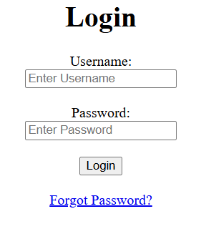
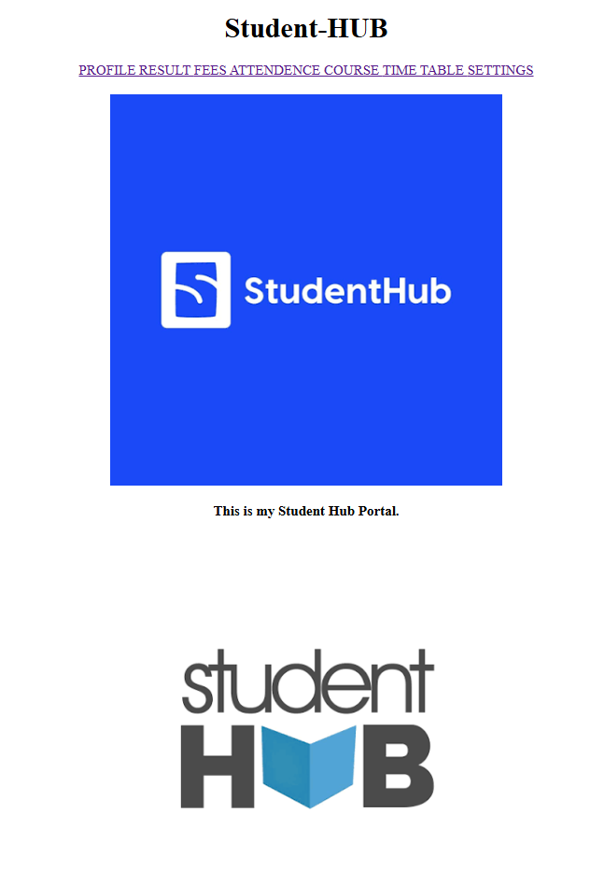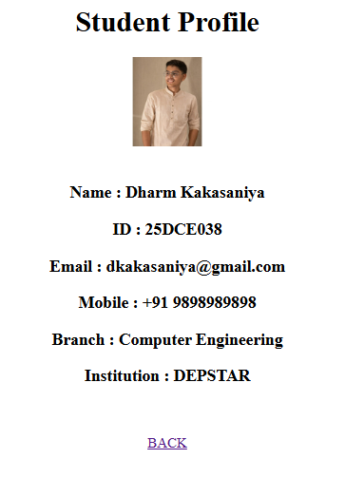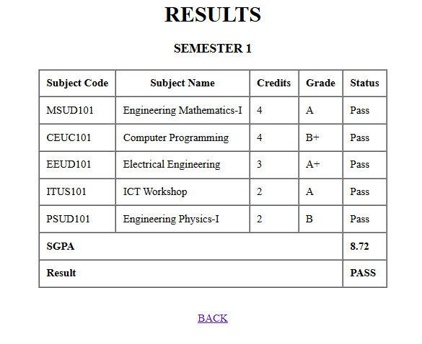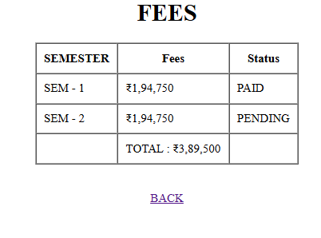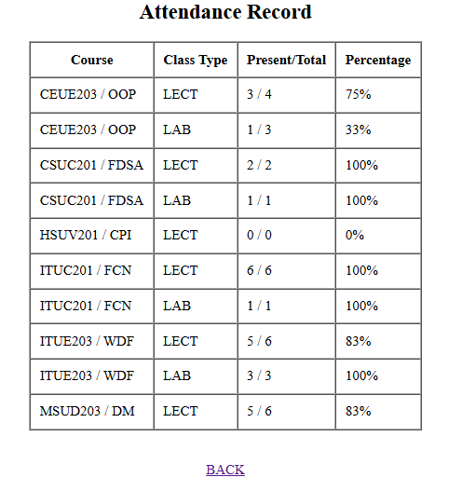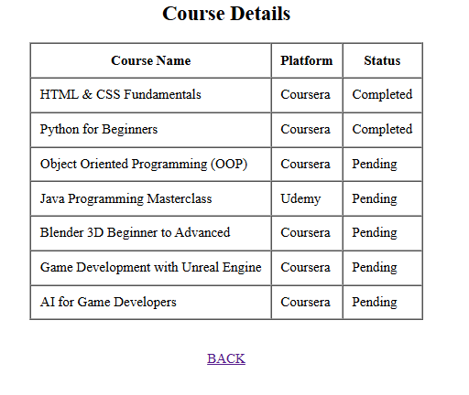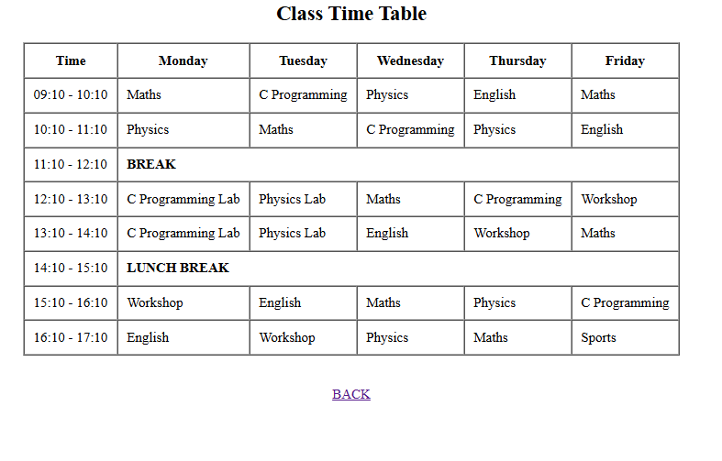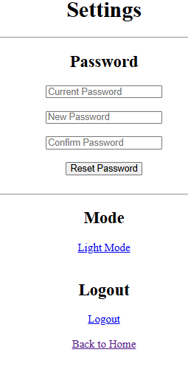

Description: This all are the pages of student hub portal with only HTML.

GitHub Repository Link: https://github.com/dharmkakasaniya01/Student

Challenges Faced:
While performing this practical, I faced difficulty in selecting the correct semantic HTML5 tags and maintaining a consistent page structure. I also found it challenging to make the pages accessibility-friendly.

Learning Outcomes:

After completing this practical, I learned how to create semantic HTML5 pages with proper page structure and accessibility features. I also learned to maintain consistency across multiple web pages.

Faculty Remarks:

